Themes across Control and Reinforcement Learning
We invite registrations for a workshop on Themes across Control and Reinforcement Learning: https://www.cwi.nl/en/events/cwi-research-semester-programmes/workshop-themes-across-control-and-reinforcement-learning/
Please recommend this also to your students, post-docs and other colleagues!
Control theory and reinforcement learning converge on a shared objective: facilitating autonomous, real-time decision-making to optimize dynamical processes. Historically, these disciplines have diverged in assumptions regarding available prior information and in analytical techniques applied. However, recent advances bridging the two domains are fostering collaborations. As part of a research semester on Control Theory and Reinforcement Learning at CWI, Amsterdam, NL, we have a workshop on broad themes across these topics.
Dates: 24-25 March 2025
Venue: CWI (Research Institute for Mathematics and Computer Science), Amsterdam,
We have a line-up of renowned speakers:
Ann Nowé, Vrije Universiteit Brussel, Belgium
Bert Kappen, Radboud Univ, Nijmegen, Netherlands
Davide Grossi, Univ of Amsterdam, University of Groningen, Netherlands
Frans Oliehoek, TU Delft, Netherlands
Harri Lähdesmäki, Aalto University, Finland
Jens Kober, TU Delft, Netherlands
Sean Meyn, Univ. of Florida, USA
Sofie Haesaert, Eindhoven University of Technology, Netherlands

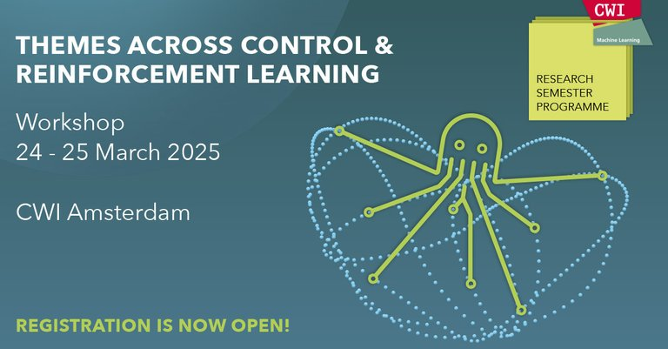

Part of the research semester programme, which includes a spring school (17-21 March).
Download and advertise the poster!

