Math4NL community event 2025
On Friday December 5 the community event of Math4NL will take place at the campus of TU Eindhoven, at Zwarte Doos. This year’s annual event offers two exciting opportunities to learn, connect, and collaborate, both focusing on how mathematics builds bridges between academia, industry, and society.
In the morning, early career researchers (PhD, Postdoc, starting UD) can join a practical workshop on how to build and use a professional network. The morning session is coordinated by Sandjai Bhulai (professor of Business Analytics at Vrije Universiteit Amsterdam), Mark Roest (CEO of VORtech and chair of innovation committee of Platform Wiskunde Nederland) and Wil Schilders (Professor of industrial mathematics at the TU/e and Director of PWN).
In the afternoon, the Math4NL Community Event brings together mathematicians from universities, industry, and government to explore the theme: “From University to Practice: Mathematicians Making Impact”. Join for one or both sessions, and expand your professional network while discovering how mathematics drives innovation across sectors.
Check the website of the event for the full program and updates. The registration costs are
- Morning networking workshop – €25 (including lunch)
- Afternoon community event – additional €25
If you are interested, then you can fill in the form in the next page and send it to info@math4nl.nl (be careful of the nl.nl!)
My personal experience is that such an event can help significantly in exploring new options, which is also why I always join 3-4 such events per year.

Nicos Starreveld
Verantwoordelijk voor publiciteit, outreach en wetenschapscommunicatie bij
Platform Wiskunde Nederland


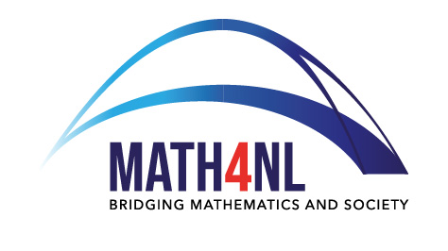

Math4NL Networking Event – Registration Form
Date: December 5, 2025
Location: Filmzaal, Zwarte Doos, TU Eindhoven

Name: ___________________________________________
Affiliation: _______________________________________
Email address: ____________________________________

Participation
☐ I will attend the Networking Event (morning session) – €25 (including lunch)
☐ I will attend the Math4NL Community Event (afternoon session) – additional €25
(Both boxes may be ticked if attending the full day.)

Dietary restrictions (if any): ________________________________

Total fee: €__________
Payment details
Please transfer the participation fee to:
Account name: Stichting Platform Wiskunde Nederland
IBAN: NL95INGB0005864482
Reference: “Math4NL Event – [Your Name]”

Please send this completed form to: info@math4nl.nl

